2024 Lincoln Essay Contest Winners at Hildene, The Lincoln Family Home.

### **LINCOLN ESSAY WINNERS CELEBRATED AT HILDENE**

#### **MANCHESTER, Vt. (May 21, 2024) — Students, families, teachers, principals, judges, and guests from across Vermont gathered in Manchester on Sunday to honor the winners of the 18th annual Lincoln Essay Competition at Hildene, The Lincoln Family Home. This year’s topic focused on the impact of artificial intelligence (AI) across various fields and sectors in our society.**

At Sunday's award ceremony, the contest winners read their essays to a supportive crowd and enjoyed a luncheon. Every student received guest passes to visit Hildene and a cash prize with an acknowledgement letter. The celebration was the culmination of a months-long process in which Hildene received a remarkable 211 submissions statewide, showcasing diverse perspectives on AI's role in different sectors. After rigorous evaluation, first, second, and third-place winners were chosen from four Vermont regions encompassing the whole state, and three honorable mentions were then selected from the combined pool of finalists.

"This year's theme for the essay competition reflects Lincoln's lifelong appreciation for technological innovation," said Brian Keefe, President for Hildene. "One of President Lincoln's lesser-known accomplishments is that he was an inventor—he is the only U.S. President that filed and received a patent. We are incredibly impressed with the winning essays showcasing each student's exploration of Artificial Intelligence."

President Lincoln had an enduring fascination with technology and its potential to transform lives. In his ["Discoveries and Inventions](https://teachingamericanhistory.org/document/first-lecture-on-discoveries-and-inventions/)" lecture, he reflected on the essential human innovations that have shaped the course of history (the printing press, steam-power, etc.). Today, the increasingly pervasive use of artificial intelligence (AI) has the potential to make a similarly profound impact on society.

This year’s essay prompt challenged students to examine the transformational power of artificial intelligence within any field of interest of their choosing and to explain whether they believe the benefits outweigh the risks. Notably, most students highlighted concerns about AI's potential to overshadow and even eliminate human creativity and sensitivity in fields like journalism, law enforcement, writing, and the arts. Many also expressed fear that the careers they might want to pursue may no longer be possible if AI replaces many of the jobs currently held by humans. Still others found more promise than harm in using AI for areas such as designing for safety, medical diagnostics, climate resilience and sports analytics––provided biases can be eliminated from the data collected and used.

“Every year, I look forward to meeting the students whose essays are crafted with such care. Their ability to analyze complex topics and thoughtfully, and often passionately, articulate their perspectives is deeply moving," said Stephanie Moffet Hynds, Programming Director for Hildene, following the awards ceremony. "This was definitely the case again this year as the students read their essays with poise, conviction, and sincerity. They give us reason to feel hopeful about the future.”

*For more information about the Lincoln Essay Competition, please contact:*

### **Stephanie Moffett Hynds**

Programming Director, Hildene, The Lincoln Family Home

* [stephanie@hildene.org](mailto:stephanie@hildene.org)
* 802-367-7960
* hildene.org

*To read the first-place essays in their entirety and to learn more about the competition and Hildene, please visit our website:*

[Lincoln Essay Competition | Hildene](https://hildene.org/index.php/learning/lincoln_essay)

"…in the world's history, certain inventions and discoveries occurred, of peculiar value, on account of their great efficiency in facilitating all other inventions and discoveries.”

For photos of Sunday's awards ceremony, please visit:

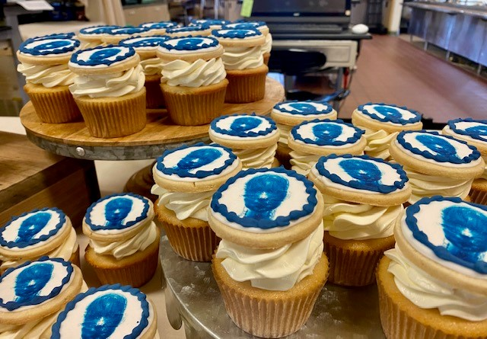

[Lincoln Essay Awards Ceremony](https://hildene.prezly.com/media/album/26878)

Nestled in the picturesque town of Manchester, Vermont, Hildene offers visitors a captivating experience of the enduring legacy of the Lincoln...

#### **LIST OF WINNERS**

For a list of winners and a summary of each winning entry, please visit:

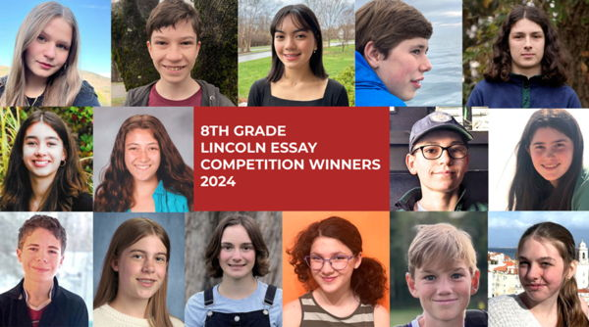

[LINCOLN ESSAY COMPETITION 2024 WINNERS](https://hildene.prezly.com/lincoln-essay-competition-2024-winners)

With brief subject matter description for each winner.

A prize of $500 for first place, $400 for second place, $300 for third place, and $200 for honorable mention were awarded to the following:

**Region One** (Grand Isle, Franklin, Orleans, Essex, Lamoille, Caledonia, and Washington Counties):

* + 1st Place: Ursa Goldenrose, Hazen Union School, Hardwick
  + 2nd Place: Helena DeVore, Peoples Academy Middle Level, Morrisville
  + 3rd Place: Ava Stratman, Peoples Academy Middle Level, Morrisville
* **Region Two** (Chittenden County):
  + 1st Place: Maelyn Slavik, Edmunds Middle School, Burlington
  + 2nd Place: Hanna Schold, Mater Christi School, Burlington
  + 3rd Place: Britta Fitzgerald, Edmunds Middle School, Burlington
  + Honorable Mentions: Tegan Bushey and Isa Cramer, Edmunds Middle School, Burlington; Elle Lipkin, Lake Champlain Waldorf School, Shelburne
* **Region Three** (Addison, Rutland, and Bennington Counties):
  + 1st Place: Levi Stoll, Maple Street School, Manchester Center
  + 2nd Place: Timmy Fitzsimmons, Maple Street School, Manchester Center
  + 3rd Place: Madison King, Mount Abraham Union Middle School, Bristol
* **Region Four** (Orange, Windsor, and Windham Counties):
  + 1st Place: Declan Read-Murrell, Upper Valley Waldorf School, Quechee
  + 2nd Place: Ezra Keim, Hilltop Montessori School, Brattleboro
  + 3rd Place: Ashton Perkins, Upper Valley Waldorf School, Quechee

#### **MEDIA GALLERY**

For photos of each winner, please visit:

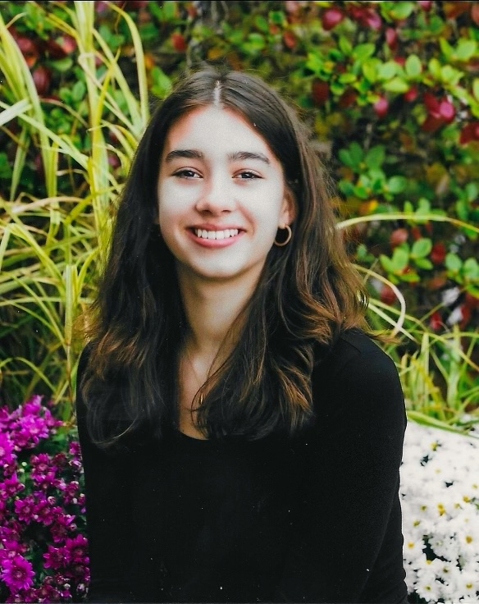

[Lincoln Essay Competition 2024](https://hildene.prezly.com/media/album/26734)

Nestled in the picturesque town of Manchester, Vermont, Hildene offers visitors a captivating experience of the enduring legacy of the Lincoln...